-EASTERN INTERNATIONAL UNIVERSITY
SCHOOL OF COMPUTING
AND INFORMATION TECHNOLOGY Course Code: CSE 202

Student’s Full Name: Student ID:
Date: June 6, 2025 Signature:
* Students are allowed to use a handwritten A4 sheet
1. Provide the definitions of the following concepts (20đ).
- Spanning tree: Given connected undirected graph G(V,E), a spanning tree is a subgraph of G that V’ ⊆V; E’⊆E, include all of the vertices (V’ = V), form a tree (no cycle), so E’ has |V|-1 edges.
- Euler path: In graph theory, the Euler path is a path that visits each node from the graph exactly one.
- Connected component (undirected graph): A connected component of a graph G(V,E) is a connected subgraph of G that is not a proper subgraph of another connected graph of G. The connected component of graph G is a maximal connected subgraph of G.
- Bridge: A bridge is an edge in an undirected graph that if removed increases the number of connected components of the graph.
- Complete graph: Given the graph G(V,E) which has n vertices, the complete graph dented by Kn is a simple graph that contains exactly one edge between each pair of distinct vertices.
2. List 3 ways to check if an undirected graph is a tree. (10đ)
- Check: the number of edges equals the number of vertices - 1 and the graph must be connected.
- Check: the number of vertices equals the number of vertices - 1 and the graph must not contain cycle
- Check: the graph must be connected and not contain a cycle.
3. Assuming you have implemented Dijkstra's algorithm to find the shortest path from A to B, how would you apply the algorithm to perform the following tasks? (10đ)
Count the number of shortest paths from A to B:
- We call d[i] the shortest path, count[i] is the number of shortest paths from A to i. When we update d[i] (the distance to i), we also update count[v]. Explanation: d[v]=d[u]+w(u,v) and count[v]=count[u], if d[v] equals d[u]+w(u,v) then count[v]+=count[u]. Finally, the answer is count[B].
Count the number of shortest paths from A to B which pass through a specified node C?
- We call dA[i] is the shortest path, countA[i] is the number of the shortest paths from A to i, and dC[i] is the shortest path, countC[i] is the number of the shortest paths from C to i. When we update dA[i] (or dC[i]), we also update countA[i] (or countC[i]). Finally, if dA[C] + dC[B] equals dA[B] then the answer is countA[C] * countC[B], else it is 0.
4. Construct the binary search tree from Post Order traversal (10 đ)
Post-order: 5, 7, 6, 12, 20, 17, 15, 30, 28, 25, 40, 50, 45, 35, 22
Cách giải: Những nút left là nhỏ hơn giá trị của nút root, right là lớn hơn nút root
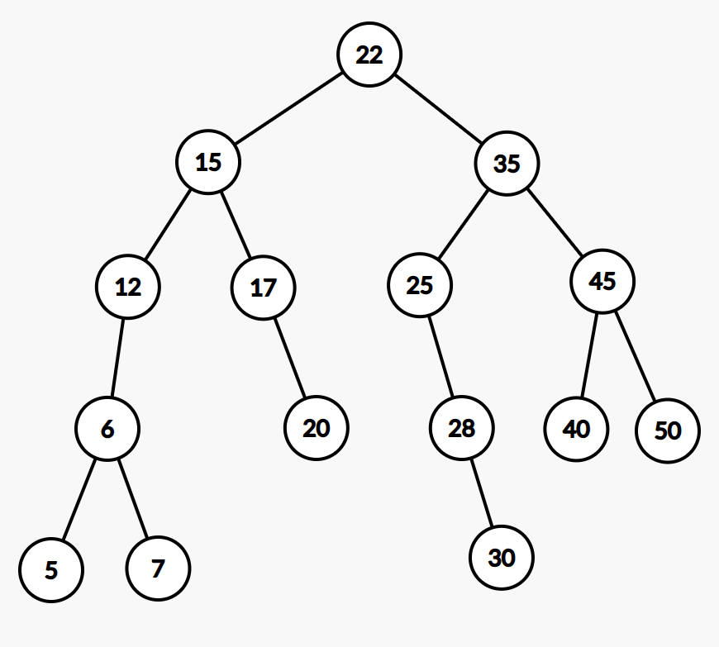
5. Find a Euler path using Fleury’s or Hierholzer’s algorithm. (10 đ)
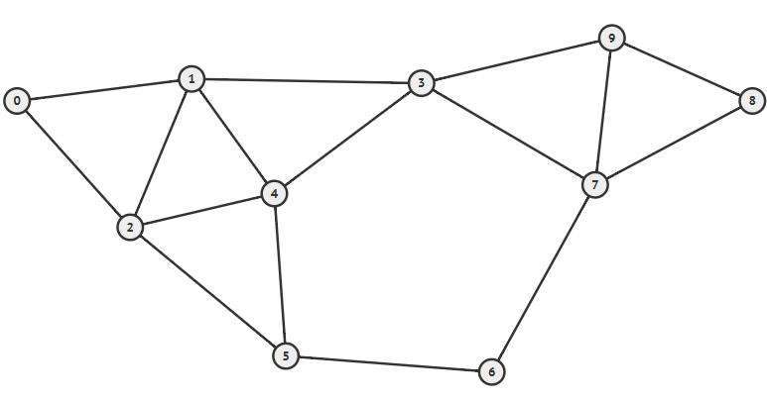
- Algorithm name: Fleury
- The Euler path: 5 - 2 - 0 - 1 - 3 - 9 - 8 - 7 - 6 - 5 - 4 - 1 - 2 - 4 - 3 - 7 - 9
- Algorithm name: Hierholzer
- The Euler path: 5 - 6 - 7 - 9 - 8 - 7 - 3 - 4 - 2 - 0 - 1 - 2 - 5 - 4 - 1 - 3 - 9
6. List the edges selected in order when applying Kruskal's algorithm to find the minimum spanning tree in the following graph. (10đ)
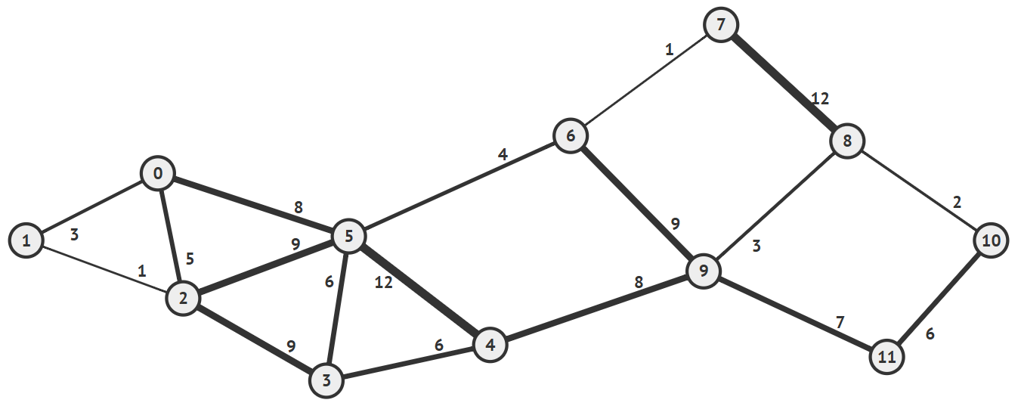
Components = [0, 1, 2, 6, 7, 5, 3, 4, 8, 10, 9, 11]
Edges = {(1,2), (6,7), (8, 10), (1, 0), (9, 8), (5, 6), (3, 5), (3, 4), (10, 11), (0, 5), (4, 9)
7. Demonstrate the Prim’s algorithm for the following graph. You should start at the vertex which is equal to the last digit of your IRN. (10đ)
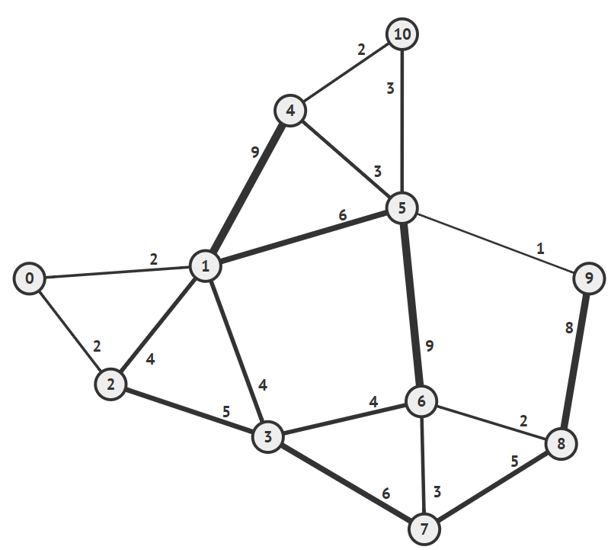
Edges ={(7-6), (6-8), (6-3), (3-1), (1-0), (0-2), (1-5), (5-9), (5-10), (10-4)}

8. Find the shortest path from 0 to other vertices using Dijkstra algorithm (20đ):
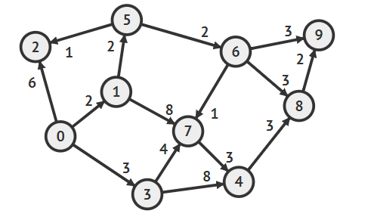

STT | 0 | 1 | 2 | 3 | 4 | 5 | 6 | 7 | 8 | 9
1 |  | 2, 0 | 6, 0 | 3, 0 | +ထ, null | +ထ, null | +ထ, null | +ထ, null | +ထ, null | +ထ, null
2 |  |  | 6, 0 | 3, 0 | +ထ, null | 4, 1 | +ထ, null | 10, 1 | +ထ, null | +ထ, null
3 |  |  | 5, 5 | 3, 0 | +ထ, null |  | 6, 5 | 10, 1 | +ထ, null | +ထ, null
4 |  |  | 5, 5 |  | 11, 3 |  | 6, 5 | 7, 3 | +ထ, null | +ထ, null
5 |  |  |  |  | 11, 3 |  | 6, 5 | 7, 3 | +ထ, null | +ထ, null
6 |  |  |  |  | 11, 3 |  |  | 7, 3 | 9, 6 | 9, 6
7 |  |  |  |  | 10, 7 |  |  |  | 9, 6 | 9, 6
8 |  |  |  |  | 10, 7 |  |  |  | 9, 6
9 |  |  |  |  | 10, 7

